Joseph Crockett  
ES 207: Environmental Data Analysis  
April 11st, 2016

**Homework Assignment 8: Time & Space**

**Objective Statement:**

In a previous analysis, I determined the number of flood events on the Consumnes river over the last hundred years (1907~2015) in order to determine whether localized aquifers would benefit from purposeful flooding of the floodplain. A related concern is deadzones on the floodplain would arise from decreases in respiration, negatively impacting fish growth.

**Methods:**

A spatial dataset of the dead zone in the Triangle Floodplain in the Cosumnes River Preserve was obtained. Following exploratory data analysis, plots of four variables (elevation, chlorophyll concentration, dissolved oxygen, and temperature) from two dates (2/16/07 and 2/17/07) were created. Finally, a shiny app with five dates and five variables was built for direct user comparision.

**Data:**

The data are from a triangular shaped floodplain on the Consumnes River Preserve obtained on dates 2/16, 2/17, 2/18, 2/23, and 2/28 of 2007. The floodplain is constrained on the western diagonal edge by an unbreached levee, while the east and south levees have been breached in two spots each. The plain was previously agricultural land dedicated to tomato farming. A large y shaped pond and a smaller pond were constructed in the center for habitat heterogeneity (Ahearn et al. 2006). Code:

pt_shp <- readShapePoints("~/Desktop/General/Spring 2016/ES 207/Labs/Projects/Lab-1/Data/ahearn_allobs/allobs.shp")  
  
head(pt_shp)

## coordinates ID DateTime_ Temp DO__ SpCond TDS Turbidity_  
## 0 (640624.5, 4237716) 1 2005-02-16 10.22 103.7 99 64 11.5  
## 1 (639727.4, 4236968) 2 2005-02-16 14.94 55.1 161 105 13.7  
## 2 (639753.8, 4236958) 3 2005-02-16 13.89 53.3 147 95 9.5  
## 3 (639788.6, 4236969) 4 2005-02-16 13.52 49.6 149 97 9.4  
## 4 (639858.6, 4236970) 5 2005-02-16 14.01 60.8 140 91 14.1  
## 5 (639928.8, 4236961) 6 2005-02-16 13.89 72.2 137 89 7.5  
## Chlorophyl Latitude Longitude Elevati SpineDi direction X  
## 0 2.4 38.2765 -121.3923 4.078768 320.3623 211 640624.5  
## 1 6.9 38.2699 -121.4027 3.600000 420.1952 78 639727.4  
## 2 7.6 38.2698 -121.4024 3.709091 397.3160 76 639753.8  
## 3 7.6 38.2699 -121.4020 3.600000 359.4496 76 639788.6  
## 4 7.9 38.2699 -121.4012 3.600000 292.2054 73 639858.6  
## 5 7.0 38.2698 -121.4004 3.600000 230.7899 65 639928.8  
## Y  
## 0 4237716  
## 1 4236968  
## 2 4236958  
## 3 4236969  
## 4 4236970  
## 5 4236961

summary(pt_shp) #Are x and y using cartesian coordinates?

## Object of class SpatialPointsDataFrame  
## Coordinates:  
## min max  
## coords.x1 639709.9 640633.2  
## coords.x2 4236956.9 4237737.9  
## Is projected: NA   
## proj4string : [NA]  
## Number of points: 1108  
## Data attributes:  
## ID DateTime_ Temp DO__   
## Min. : 1.0 Min. :2005-02-16 Min. :10.22 Min. : 38.60   
## 1st Qu.: 277.8 1st Qu.:2005-02-17 1st Qu.:12.04 1st Qu.: 85.17   
## Median : 554.5 Median :2005-02-18 Median :13.15 Median : 99.10   
## Mean : 554.5 Mean :2005-02-20 Mean :13.27 Mean : 97.81   
## 3rd Qu.: 831.2 3rd Qu.:2005-02-23 3rd Qu.:14.00 3rd Qu.:112.70   
## Max. :1108.0 Max. :2005-02-28 Max. :21.08 Max. :197.40   
## SpCond TDS Turbidity_ Chlorophyl   
## Min. : 96.0 Min. : 62.00 Min. : 4.60 Min. :-0.800   
## 1st Qu.:101.0 1st Qu.: 65.00 1st Qu.: 7.10 1st Qu.: 3.000   
## Median :126.0 Median : 82.00 Median :11.90 Median : 4.200   
## Mean :119.8 Mean : 77.82 Mean :12.35 Mean : 5.223   
## 3rd Qu.:129.0 3rd Qu.: 84.00 3rd Qu.:17.00 3rd Qu.: 6.800   
## Max. :205.0 Max. :133.00 Max. :34.30 Max. :23.500   
## Latitude Longitude Elevati SpineDi   
## Min. :38.27 Min. :-121.4 Min. :2.122 Min. :-3.403e+38   
## 1st Qu.:38.27 1st Qu.:-121.4 1st Qu.:2.914 1st Qu.: 3.600e+01   
## Median :38.27 Median :-121.4 Median :3.264 Median : 5.700e+01   
## Mean :38.27 Mean :-121.4 Mean :3.195 Mean :-3.071e+35   
## 3rd Qu.:38.27 3rd Qu.:-121.4 3rd Qu.:3.400 3rd Qu.: 1.150e+02   
## Max. :38.28 Max. :-121.4 Max. :4.600 Max. : 4.380e+02   
## direction X Y   
## Min. :-32768.0 Min. :639710 Min. :4236957   
## 1st Qu.: 83.0 1st Qu.:640170 1st Qu.:4237016   
## Median : 175.0 Median :640365 Median :4237115   
## Mean : 157.4 Mean :640309 Mean :4237160   
## 3rd Qu.: 295.0 3rd Qu.:640474 3rd Qu.:4237268   
## Max. : 360.0 Max. :640633 Max. :4237738

unique(pt_shp$DateTime_)

## [1] "2005-02-16" "2005-02-28" "2005-02-23" "2005-02-18" "2005-02-17"

#New dataframes for each date  
pt_shp_21605 <- subset(pt_shp, DateTime_ == "2005-02-16")  
pt_shp_21705 <- subset(pt_shp, DateTime_ == "2005-02-17")  
  
#The values of X and Y are in UTM projection terms. However, for a final report, I would think that stakeholders would better grasp longitude and latitude values, unless they were previously familiar with UTM.  
  
#Interpolating points into raster for each date. x = long, y = lat, z = elevation, just to see  
r_21605 <- interp(x = pt_shp_21605$Longitude, y = pt_shp_21605$Latitude, z = pt_shp_21605$Elevati, duplicate = "mean")  
  
r_21605_m <- data.frame(Elevation = melt(r_21605$z)$value, x = rep(r_21605$x, each = 40), y = rep(r_21605$y, 40)) #melting into longform so that I can use ggplot  
  
r_21705 <- interp(x = pt_shp_21705$Longitude, y = pt_shp_21705$Latitude, z = pt_shp_21705$Elevati, duplicate = "mean")  
image(r_21705)

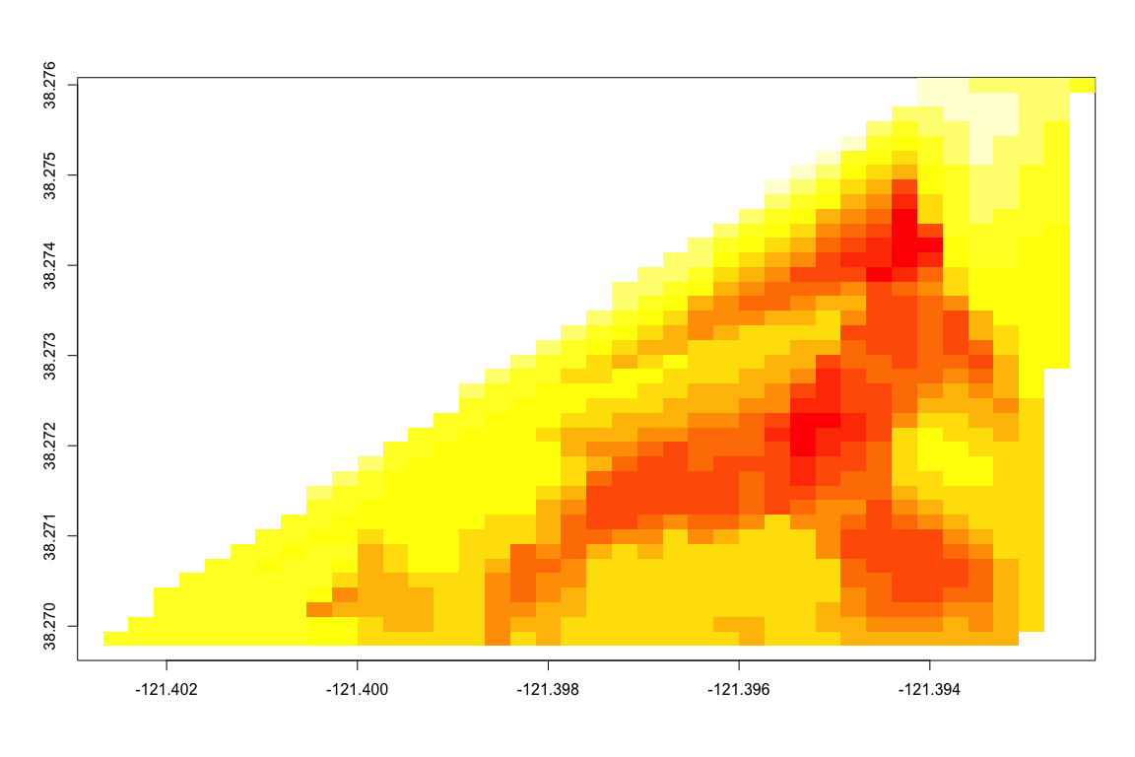

r_21705_m <- data.frame(Elevation = melt(r_21705$z)$value, x = rep(r_21705$x, each = 40), y = rep(r_21705$y, 40))  
  
#Test plots of elevation  
ggplot(r_21605_m, aes(x = x, y = y, z = Elevation, fill = Elevation)) + geom_raster() + stat_contour(color = "grey50", alpha = 1/5) + scale_fill_distiller(palette="BrBG", direction = 1, na.value="white")+ theme_minimal()

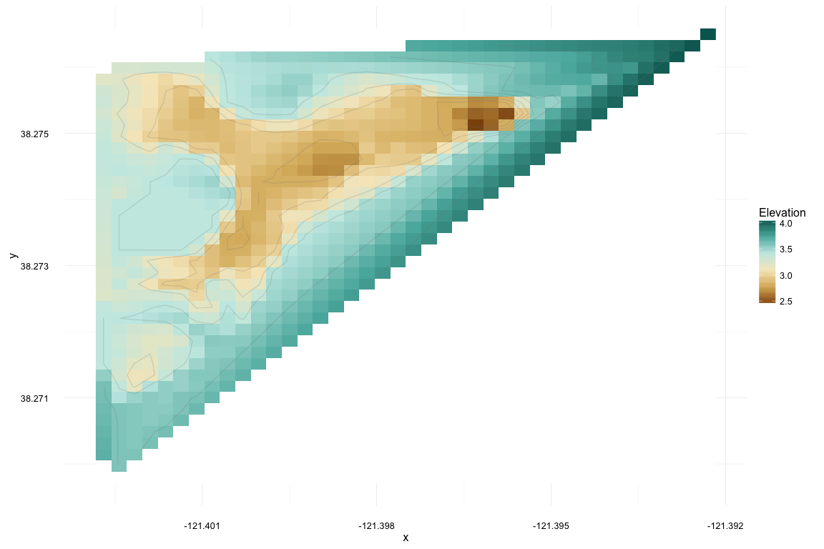

ggplot(r_21705_m, aes(x = x, y = y, z = Elevation, fill = Elevation)) + geom_raster() + stat_contour(color = "grey50", alpha = 1/5) + scale_fill_distiller(palette="BrBG", direction = 1, na.value="white")+ theme_minimal()

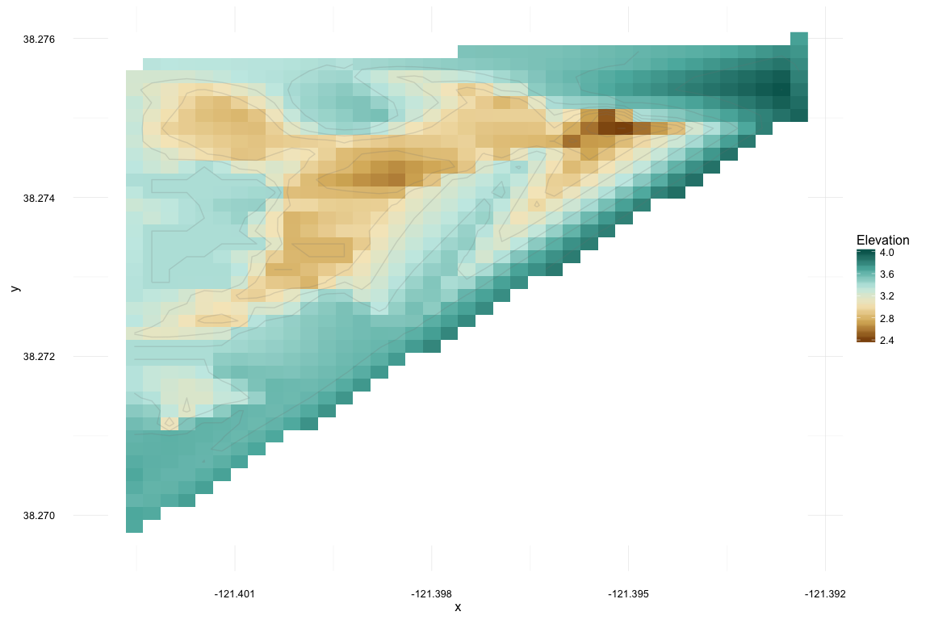

#the plot seems to be upside down.   
r_21605_m <- melt(r_21605$z)   
r_21605_m$Var2 = rep(r_21605$y, each = 40)  
r_21605_m$Var1 = rep(r_21605$x, 40)  
colnames(r_21605_m) <- c("x", "y", "Elevation")  
  
ggplot(r_21605_m, aes(x = x, y = y, z = Elevation, fill = Elevation)) + geom_raster() + stat_contour(color = "grey50", alpha = 1/5) + scale_fill_distiller(palette="BrBG", direction = 1, na.value="white")+ theme_minimal()

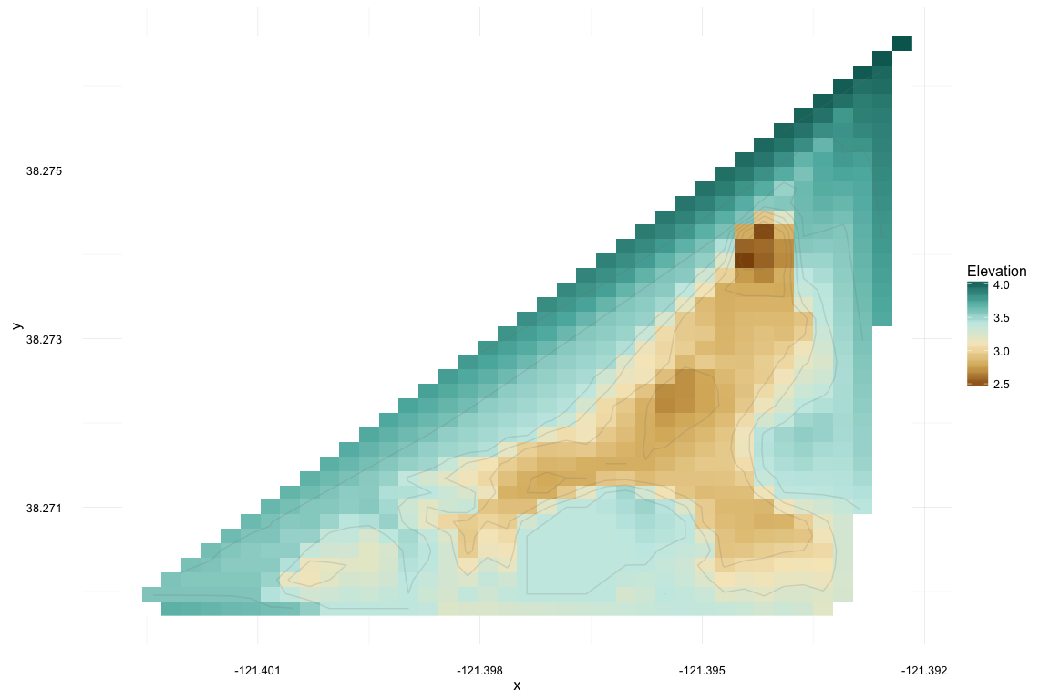

#Perspective plots  
#For 2/16/05 and 2/17/05, rasters of temp, chloro, and DO:  
  
ch_16 <- interp(x = pt_shp_21605$Longitude, y = pt_shp_21605$Latitude, z = pt_shp_21605$Chlorophyl, duplicate = "mean")  
image(ch_16)

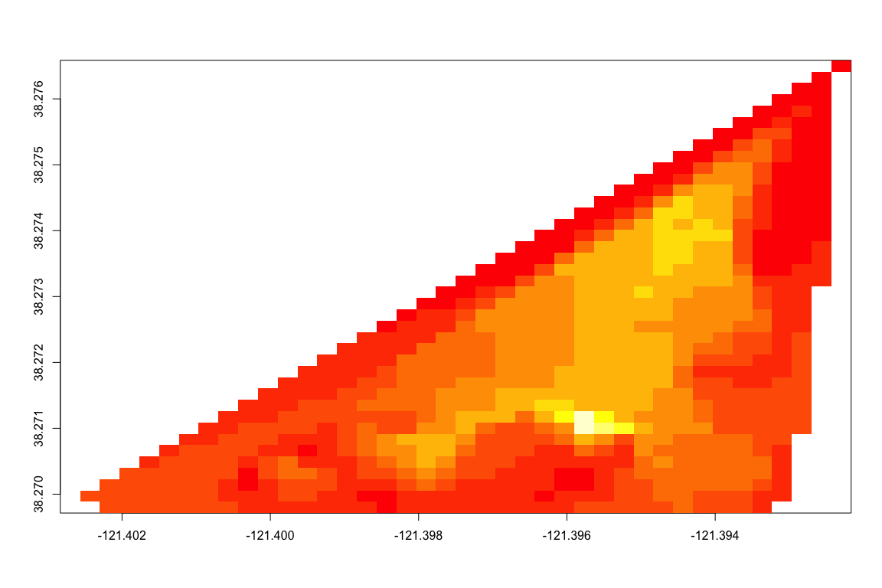

ch_16m <- melt(ch_16$z)  
ch_16m$Var2 = rep(ch_16$y, each = 40)  
ch_16m$Var1 = rep(ch_16$x, 40)  
colnames(ch_16m) <- c("x", "y", "Chlorophyll")  
t_16 <-interp(x = pt_shp_21605$Longitude, y = pt_shp_21605$Latitude, z = pt_shp_21605$Temp, duplicate = "mean")  
t_16m <- melt(t_16$z)   
t_16m$Var2 = rep(t_16$y, each = 40)  
t_16m$Var1 = rep(t_16$x, 40)  
colnames(t_16m) <- c("x", "y", "Temperature")  
do_16 <- interp(x = pt_shp_21605$Longitude, y = pt_shp_21605$Latitude, z = pt_shp_21605$DO__, duplicate = "mean")  
do_16m <- melt(do_16$z)   
do_16m$Var2 = rep(do_16$y, each = 40)  
do_16m$Var1 = rep(do_16$x, 40)  
colnames(do_16m) <- c("x", "y", "Dissolved_O2")  
  
ch_17 <- interp(x = pt_shp_21705$Longitude, y = pt_shp_21705$Latitude, z = pt_shp_21705$Chlorophyl, duplicate = "mean")  
ch_17m <- melt(ch_17$z)   
ch_17m$Var2 = rep(ch_17$y, each = 40)  
ch_17m$Var1 = rep(ch_17$x, 40)  
colnames(ch_17m) <- c("x", "y", "Chlorophyll")  
t_17 <-interp(x = pt_shp_21705$Longitude, y = pt_shp_21705$Latitude, z = pt_shp_21705$Temp, duplicate = "mean")  
t_17m <- melt(t_17$z)  
t_17m$Var2 = rep(t_17$y, each = 40)  
t_17m$Var1 = rep(t_17$x, 40)  
colnames(t_17m) <- c("x", "y", "Temperature")  
do_17 <- interp(x = pt_shp_21705$Longitude, y = pt_shp_21705$Latitude, z = pt_shp_21705$DO__, duplicate = "mean")  
do_17m <- melt(do_17$z)   
do_17m$Var2 = rep(do_17$y, each = 40)  
do_17m$Var1 = rep(do_17$x, 40)  
colnames(do_17m) <- c("x", "y", "Dissolved_O2")  
  
  
# image/contour plots, 2/16/07  
p1 <- ggplot(ch_16m, aes(x = x, y = y, z = Chlorophyll, fill = Chlorophyll)) +  
 geom_raster() +  
 stat_contour(color = "black", alpha = 1/4) +  
 scale_fill_distiller(name = "Chlorophyll (μg L−1)", palette="Spectral", direction = 1, na.value="white")+  
 theme_minimal() +  
 theme(legend.title = element_text(size = 10), legend.justification=c(0,1), legend.position=c(0,1))+  
 labs(x = "Longitude", y = "Latitude")  
#Chlorophyl is in terms of micrograms / liter (ug L^-1)  
  
p2 <- ggplot(t_16m, aes(x = x, y = y, z = Temperature, fill = Temperature)) +  
 geom_raster() +  
 stat_contour(color = "black", alpha = 1/4) +  
 scale_fill_distiller(name = "Temperature (°C)", palette="Oranges", direction = 1, na.value="white")+  
 theme_minimal() +  
 theme(legend.title = element_text(size = 10), legend.justification=c(0,1), legend.position=c(0,1))+  
 labs(x = "Longitude", y = "Latitude")#Temperature (c)  
  
p3 <- ggplot(do_16m, aes(x = x, y = y, z = Dissolved_O2, fill = Dissolved_O2)) +  
 geom_raster() +  
 stat_contour(color = "black", alpha = 1/4) +  
 scale_fill_distiller(name = "Dissolved O2 (%)", palette="BuPu", direction = 1, na.value="white")+  
 theme_minimal() +  
 theme(legend.title = element_text(size = 10), legend.justification=c(0,1), legend.position=c(0,1))+  
 labs(x = "Longitude", y = "Latitude")#DO (%)  
  
#getting the colors from ggplot to use in the perspective plots  
getPalette1 = colorRampPalette(brewer.pal(9, "Spectral"))  
getPalette2 = colorRampPalette(brewer.pal(9, "Oranges"))  
getPalette3 = colorRampPalette(brewer.pal(9, "BuPu"))  
  
  
#perspective plots  
p4 <- wireframe(Chlorophyll ~ x*y, ch_16m, drape = T, aspect = c(61/87, 0.4), col.regions = (getPalette1)(100), col = F, xlab = "Longitude", ylab = " Latitude", zlab = list("Dissolved O2", rot = 90))  
p5 <- wireframe(Temperature ~ x*y, t_16m, drape = T, aspect = c(61/87, 0.4), col.regions =(getPalette2)(100), col = F, xlab = "Longitude", ylab = " Latitude",zlab = list("Dissolved O2", rot = 90))  
p6 <- wireframe(Dissolved_O2 ~ x*y, do_16m,drape = T, aspect = c(61/87, 0.4), col.regions =(getPalette3)(100), col = F, xlab = "Longitude", ylab = " Latitude", zlab = list("Dissolved O2", rot = 90))  
  
#2/16/05 plots. contour/image on top row, persp on bottom  
g1 <- grid.arrange(p1,p2,p3,p4,p5,p6, nrow = 2, ncol = 3, top = "2/16/07 Chlorophyl (μg L−1), Temperature (C), and Dissoved Oxygen (%) in the Triangle Floodplain Deadzone of the Consumnes River Preserve")

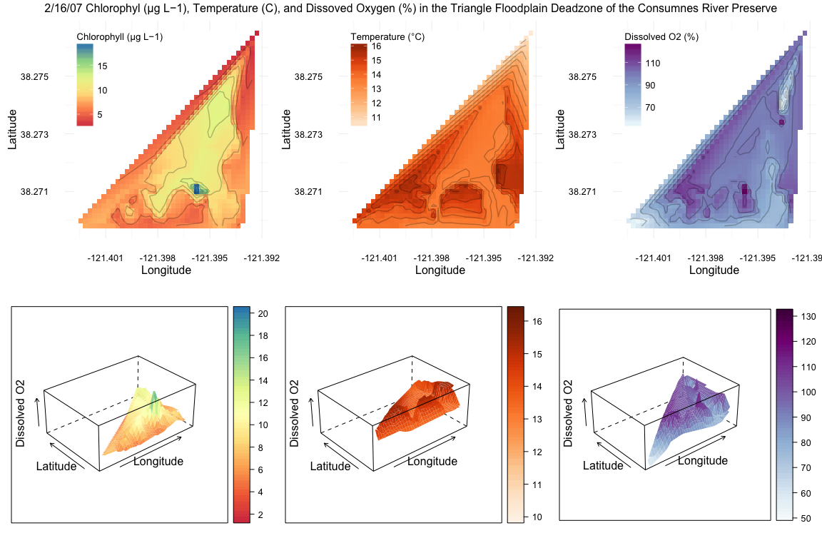

# image/contour plots, 2/17/07  
p7 <- ggplot(ch_17m, aes(x = x, y = y, z = Chlorophyll, fill = Chlorophyll)) +  
 geom_raster() +  
 stat_contour(color = "black", alpha = 1/4) +  
 scale_fill_distiller(name = "Chlorophyll (μg L−1)", palette="Spectral", direction = 1, na.value="white")+  
 theme_minimal() +  
 theme(legend.title = element_text(size = 10), legend.justification=c(0,1), legend.position=c(0,1))+  
 labs(x = "Longitude", y = "Latitude")  
  
  
p8 <- ggplot(t_17m, aes(x = x, y = y, z = Temperature, fill = Temperature)) +  
 geom_raster() +  
 stat_contour(color = "black", alpha = 1/4) +  
 scale_fill_distiller(name = "Temperature (°C)", palette="Oranges", direction = 1, na.value="white")+  
 theme_minimal() +  
 theme(legend.title = element_text(size = 10), legend.justification=c(0,1), legend.position=c(0,1))+  
 labs(x = "Longitude", y = "Latitude")  
  
  
p9 <- ggplot(do_17m, aes(x = x, y = y, z = Dissolved_O2, fill = Dissolved_O2)) +  
 geom_raster() +  
 stat_contour(color = "black", alpha = 1/4) +  
 scale_fill_distiller(name = "Dissolved O2 (%)", palette="BuPu", direction = 1, na.value="white")+  
 theme_minimal() +  
 theme(legend.title = element_text(size = 10), legend.justification=c(0,1), legend.position=c(0,1))+  
 labs(x = "Longitude", y = "Latitude")  
  
  
  
  
#perspective plots  
p10 <- wireframe(Chlorophyll ~ x*y, ch_17m, drape = T, aspect = c(61/87, 0.4), col.regions = (getPalette1)(100), col = F, xlab = "Longitude", ylab = " Latitude", zlab = list("Chlorophyll (μg L−1)", rot = 90))  
p11 <- wireframe(Temperature ~ x*y, t_17m, drape = T, aspect = c(61/87, 0.4), col.regions = (getPalette2)(100), col = F, xlab = "Longitude", ylab = " Latitude", zlab = list("Temperature (°C)", rot = 90))  
p12 <- wireframe(Dissolved_O2 ~ x*y, do_17m,drape = T, aspect = c(61/87, 0.4), col.regions = (getPalette3)(100), col = F, xlab = "Longitude", ylab = " Latitude", zlab = list("Dissolved O2 (%)", rot = 90))  
  
  
g2 <- grid.arrange(p7,p8,p9,p10,p11,p12, nrow = 2, ncol = 3, top = "2/17/07 Chlorophyl (μg L−1), Temperature (C), and Dissoved Oxygen (%) in the Triangle Floodplain Deadzone of the Consumnes River Preserve")

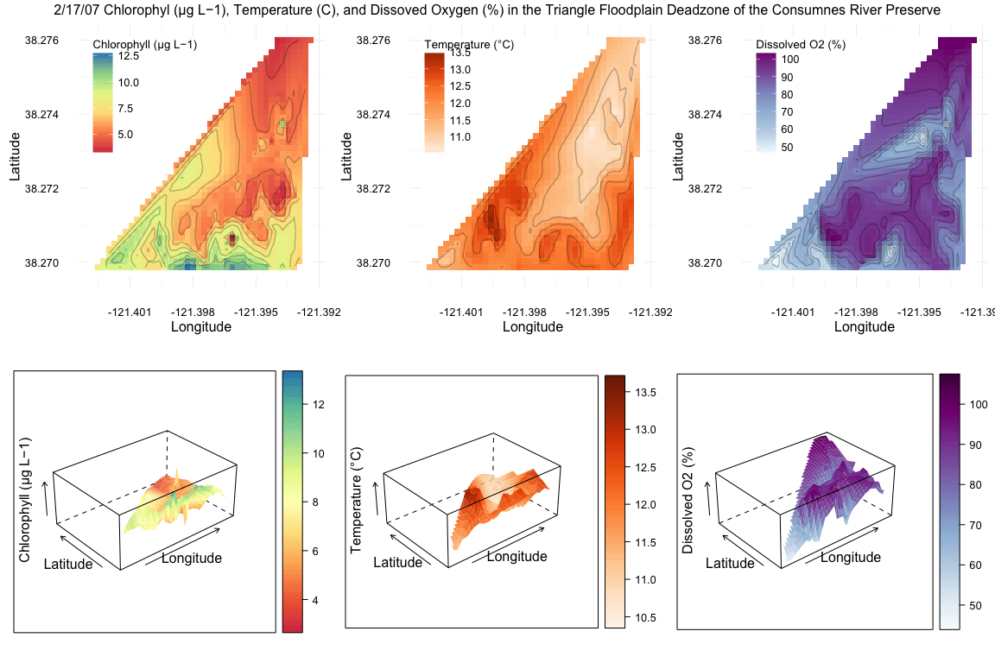

#see shiny app attached

**Results:**

Between February 16th and 17th, 2007, the elevation of the floodplain changes little, with the exception of a deepened channel along the northwest edge. Ahearn et al. 2006 noted that the floodplain was converted from agricultural land, with two ponds added for habitat. The y shaped shallow area observed in the elevation plot corresponds to the larger of the two ponds, and the smaller shallow area in the southwest corner is the other. The floodplain varies approximately 1.5 m between the lowest point (the northeast corner of the y pond) and the highest point (the northeast corner of the levee). On 2/17/07, the deepest point of the y-pond extended north and east along the western levee and the deep point dropped approximately .1 m in elevation. Chlorophyll is consistent across the 2/16 y pond (~10 μg L−1), with the exception of a spike of 15 μg L−1 on the south side of the pond. The spike in chlorophyll becomes a sink on 2/17 as areas around the y pond are innundated with chlorophyll-laden flooding. Low elevations were predominantly cooler than adjacent areas on 2/16, and temperatures drastically dropped on 2/17. With the exception of points of high dissolved oxygen content at points close to high chlorophyll production on 2/16, DO had low variation at 90~100 % saturation. High DO were found at points of high temperature and/or chlorophyll. 2/17 saw DO levels increase in areas of high chlorophyll concentration, but also in areas of high temperatures along the eastern side of the floodplains.

**Discussion:**

Chlorophyll concentrations appear to be heavily influenced by an influx of water onto the floodplain on 2/17. The southern edge, where two levee breaches allow the exit of water, seem to concentrate the chlorophyll, but it difficult to say with certainty what the connection is. The attached shiny app allows comparison of five values over five dates. The final two variables included in the app are total dissolved solids and turbidity. Turbidity shows an interesting story of the inundation of the floodplain: on day 1, 2/16, a point of high turbidity is occurring on the southern edge, at a similar point as a concentration of chlorophyll, dissolved O2, and temperature. The beginnings of a flood are evident in the northeastern corner. The following days see great turbulence from the northeast as waters rush into the system and flow through two points in the south. Reduced chlorophyll follows this path, but within two days of the initial flow, heavy concentrations of chlorophyll occur in corners of the y pond, though they do not last long. The date ranges may not be enough to make predictions regarding deadzones, but it appears that the dissolved oxygen of the floodplain increased in relation to increased turbidity. Post flood, DO levels dropped to pre flood concentrations. It is my recommendation that floods are a necessary part of this system if our intent is to reduce persistent deadzones.

**Limitations:**

Our time scale is short, reducing the number of data points that could be used to relate DO to other variables.

Citations:

Ahearn, Dylan S., et al. "Priming the productivity pump: flood pulse driven trends in suspended algal biomass distribution across a restored floodplain." Freshwater Biology 51.8 (2006): 1417-1433.